The dataset triDataLakePlacidFinal.json contains data on female finishers of the Lake Placid Ironman Triathlon from 2002 to 2021. For this exploratory analysis, we will be looking at several variables that are tracked each year for the race.

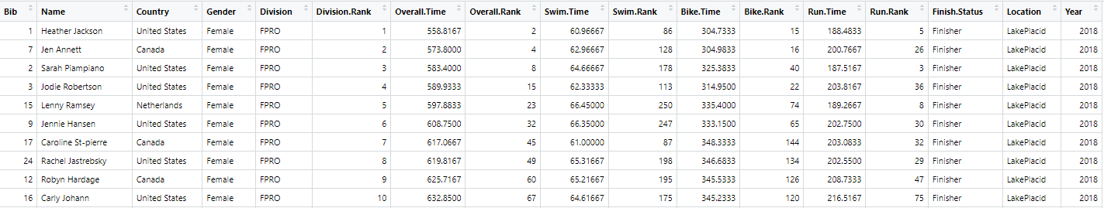

1. What are the cases?
2. Identify some categorical variables:
3. Identify some numerical variables:
4. Pose two research questions involving a single variable:
5. Pose two research questions about the relationship between two variables:

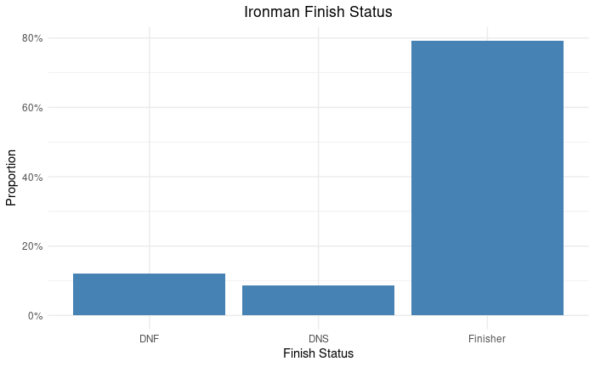**Bar Charts (One Categorical Variable)**

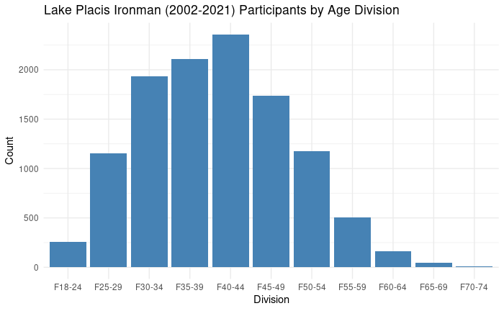

**Dot Plots (One Numerical Variable)**

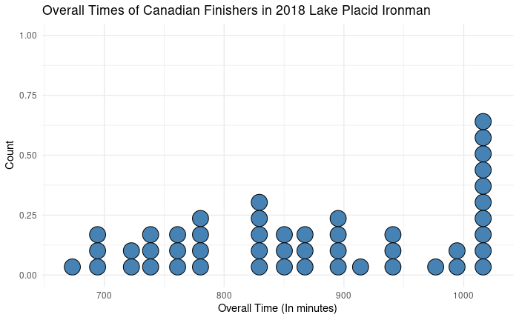

Mean = 866.48 minutes  
N = 48

What percentage of Canadian Female Finishers finished with an overall time below 800 minutes?